Lesson Title: Influencing New York Government with Lobbying
Author: Bob Keyser, Shenendehowa Central School District

Lesson Outcomes:
- Recognize the Legislative Branch’s role in creating policy and the process the Assembly and Senate use to evaluate proposed policies.
- Analyze data from graphs displaying the money spent by Special Interest Groups on lobbying decision makers in government.
- Examine First Amendment rights and how those rights guarantee and protect a citizen’s right to lobby decision makers in government.
- Develop Citizen Action Plans outlining the actions they believe would be most effective in lobbying decision makers in the New York State Legislative Branch to approve the groups desired policy outcome.
- Evaluate their classmates’ Citizen Action Plan targets, actions, and goals put forth in class presentations.

Alignment to New York State Social Studies Curriculum Framework:
12.G2b The Constitution aims to protect, among other freedoms, individual and group rights to freedom of speech, freedom of the press, freedom of assembly, freedom of petition, and freedom of religion. The extent to which these ideas exist in practice and how these protections should be applied in a changing world continues to be an ongoing civic debate.

12.G4e Citizens participate in civic life through volunteerism and advocacy, including efforts such as contacting elected officials, signing/organizing petitions, protesting, canvassing, and participating in/organizing boycotts.

12.G5 Public Policy: All levels of government—local, state, and federal—are involved in shaping public policy and responding to public policy issues, all of which influence our lives beyond what appears in the Constitution. Engaged citizens understand how to find, monitor, evaluate, and respond to information on public policy issues.

Alignment to New York State Practices:
F. Civic Participation
2. Participate in activities that focus on a classroom, school, community, state, or national issue or problem.
4. Identify situations in which social actions are required and determine an appropriate course of action.
7. Work to influence those in positions of power to strive for extensions of freedom, social justice, and human rights.
8. Fulfill social and political responsibilities associated with citizenship in a democratic society and interdependent global community by developing awareness of and/or engaging in the political process.

Lesson Materials and Procedures:
Materials:
Part I:
- Appendix A: “The Citizen Lobbyist: Influencing Change in our Society” worksheet
- Appendix B: Graphs
- Appendix C: Reasons to Hire a Lobbyist
- Appendix D: Assessment #1
Part II:
- Appendix E – Student Group Presentation
- Appendix F – Issues for Student Groups
- Appendix G – Citizen Lobbying Actions
- Appendix H – Citizen Lobbying Background Materials
- Appendix I – Group Presentation Rubric

Procedures:
Part I:
- With a partner, identify two laws students wish were different. Complete the chart on the worksheet, “The Citizen Lobbyist, Influencing Change in our Society” (Appendix A). When they have finished, have the partners circle the idea they liked best and then call on a few students to discuss their ideas.
- Tell the students that the New York State government is constantly evaluating current laws to improve them, as well as looking to create new laws to solve issues. Assign students to read the gray box in the worksheet to learn how New York State creates public policy (laws). Space is provided on the worksheet for students to take notes on the reading. Review the notes to insure they have the correct understanding.
- Read the explanation of Special Interest Groups and together develop a definition. With a partner, identify the Special Interest Groups affected by the two bills. Share out responses. Answers can include organizations like the NRA, teachers’ unions, but also can be as simple as teachers, gun owners, parents, taxpayers, etc.
- Analyze the graphs on Special Interest Groups (Appendix B) and answer the three questions on the graphs. When the partners are finished writing answers to the thought questions, discuss the answers as a class. Let students discuss and debate their opinions on the impact they think Special Interest Group donations play in creating policy.
- After the discussion, read the paragraph on lobbyists and develop a class definition of lobbyists. Next, have the students read “The Reasons to hire a Lobbyist” (Appendix C) and summarize those reasons on the worksheet. Have the partners then discuss and answer the Discussion/Thought Question on Lobbyists and then discuss as a class. Read the reason lobbying is a protected right and then have students examine their 1st Amendment rights, what they are and how they protect their right to lobby. Space is provided for students to record notes.
- After having the students write the actions they themselves could take to lobby because of their 1st Amendment rights on the worksheet, quickly go over these actions as a class.
- Tell the students in the next part of this lesson, they will have an opportunity to use these actions.
Check for Understanding:
- Lesson Part I – Assessment #1 (Appendix D)

Part II:
- Quickly review with the students the New York Legislative Branch (Assembly, Senate, law making process, special interest groups, lobbyists, First Amendment rights and possible citizen lobbying actions)
- Divide class into groups of four students. Distribute:
  - Access to their own copy of the “Student Group Presentation” PowerPoint
  - An Issue from the “Issues for Student Group Presentations.” Each group should be assigned a different issue.
  - A copy of the each of the actions (Petition, Protest, Letter to Editor/Op-Ed, Boycott, Social Media)
  - “Citizen Lobbying Background Materials”
- Tell the student groups to follow the instructions on the 1st slide of the PowerPoint and that each group member will have their own task in the presentation they will be assessed on.
Instructions on the PowerPoint read:
  - Your Group’s Task
  - Read and Understand Your Citizen Lobbying Issue
  - PowerPoint
  - Fill out the Background Slide
    - Pick 3 Actions. At least 2 actions must be either: Petition, Protest, Boycott, Letter to Editor/Op-Ed, or Social Media
    - You may choose 1 action protected by the 1st Amendment not on that list.
- When students finish their presentations, match them with a different group. Both groups should share their presentations with each other. While the 1st group presents, each member of the group listening should be filling out the Student Group Presentation Rubric. (Tell the students they will be turning these in at the end of the period, so make sure they give a quality evaluation complete with explanations for their answers).

Check for Understanding:
- Lesson Part II - At the end of the second part of the lesson, make sure you have access to each group’s presentations. Each group member should be assigned a task to be evaluated on in the presentation. Collect each student’s “Group Presentation Rubric”. The accuracy of the rubric and the students’ answers in “explanation” column will determine student understanding of actions protected by the First Amendment, Special Interest Groups, Public Policy Process (correct people in the Legislative Branch to lobby).

Part II Alternative: Design a Citizen Action Plan
To build upon students’ interest and create a more in-depth student-driven project, assign students to create a Citizen Action Plan.

Directions:
- Divide students into groups of 4 to 5.
- Assign groups to come to consensus on a current New York issue that they believe needs to be addressed. Ideally the issue will be a political issue, but students may need to do some preliminary research in order to determine the political aspect of the issue. For example, students may wish to address the issue of water pollution in their community. Additional research on the cause and extent of the problem will help them narrow down and evaluate potential solutions they are advocating for in their Citizen Action Plan. The activities in Part I of this lesson, and the lesson “Participating in Political Action in Your Local Community” could serve as the preliminary research.

- Once groups have come to consensus, assign students to research the issue by answering these questions. Adapt or add questions as needed.
- Describe the issue in detail.
- State the reason(s) why this is an important issue in our society.
- Historical background of the issue
- Statistics that prove the significance and impact of the issue
- Does it affects rights and freedoms of citizens, etc.? (If so, how?)
- Who are the stakeholders (people/groups affected) by this issue?
- Is there a current law, policy, ruling, or judicial precedent that is related to this issue?
- If the issue is a problem, what are possible solutions for the problem?
- What are some criteria that can be used to evaluate the effectiveness (or feasibility) of the solution(s)?
- Once students can fully describe the issue and have identified potential solutions, they are ready to select a solution and defend it. Students should be able to identify pros and cons of their solution (4 or 5 of each) and explain why they think their solution would be effective and feasible.
- The group should then use their research to create and present a Citizen Action Plan.
- Students should include the following in their Citizen Action Plan:
  - Explain Your Issue:
- What would you like to see happen to improve this issue (what is your issue)?
- What would you like to see happen to improve this issue (what is your goal)?
  - Who are the decision makers in New York State you will lobby?
  - What are three Special Interest Groups that will support you?
  - What are three Special Interest Groups that will oppose you?
  - Choose three actions you will use to lobby the New York State government (petition, protest, boycott, letter to editor/Op-Ed, social media campaign, etc.) and for each describe three details about your action.
- What do you hope your action will accomplish?
- Why do you believe this action will help accomplish your goal listed above?
  - Overall: Why is your Citizen Action Plan likely to succeed? Argue for why it would draw the attention of the government and citizens of the area it affects.

- Group Presentations: While each group presents their Citizen Action Plan, have their classmates act like potential donors to their cause. Each student in the audience starts with $100 contribute. Imaginary funds can only be donated in 10s ($10, $20, $30, $40, $50, $60, $70, $80, $90, $100). Students donate to the groups they believe have the most effective plan. Once they run out of money they can longer contribute. Students cannot donate to their own group. The group at the end with the most contributions wins!

Appendix A

The Citizen Lobbyist: Influencing Change in Our Society
Anticipatory Set: With your partners brainstorm 2 laws in our society that you wish were different.
What is the Current Law | How would you change this Current Law?
1.
2.

How are Laws made in New York State?
Directions: Read the information in the gray box to help you fill in the blanks in guided notes below.
New York State’s government has three branches of government, the Executive Branch (headed by the Governor), and the Judicial Branch (the Courts), and the Legislative Branch (comprised of the Senate and Assembly). The Assembly has 150 members and the Senate has 63 members.  The main job of the Legislative branch main job is to pass bills (ideas) into laws. A Bill is an idea that can only become a law if it makes it through three main steps: 1. It is passed by Assembly (the majority of the 150 members vote for it). 2 It is passed by the Senate (the majority of the 63 members vote for it). 3. It is signed into law by the Governor (the governor may also veto the bill preventing it from becoming law).  Every year the Assembly and Senate meet for 6 months (from January to June) in our state capital, Albany, proposing thousands of Bills (ideas) and passing only the most supported Bills into law. | A. For 6 months each year, _________________ Branch and the _________________ Branch meet in _______________ to propose ideas/solutions (_________) to problems and pass the ones most supported into New York State ____________.  B. The head of the Executive Branch is the _______________________.  C. The New York Legislative Branch has two chambers. The New York State _____________________ and the New York State _______________________.  D. There are 150 members in the _________________________ and 63 in the _______________________.  E. In order for a bill (idea or solution) to become law it must be passed in both the _______________________ and the _____________________ and then be signed into law by the _________________________.
Special Interest Groups
Just as you cared about the laws at the top of this sheet, New York citizens, groups, business, and organization have a lot to gain or lose when a bill becomes law. The groups that could benefit or be hurt by new policy are called Special Interest Groups.
Define: Special Interest Groups -

So if a new bill was introduced to make the school year longer, the Special Interest Groups affected would be…
(List 3) 1. 2. 3.

What if a new bill was introduced to allow New Yorkers to start driving at 14-years old, who would the Special Interest Groups be? (List 3) 1. 2. 3.
Graphs
Directions: Look at Graph A, B, and C on the handout and then answer the questions below:
A. What do these graphs show us Special Interest Groups are doing?

B. Why do you think they are doing this?

C. How do you feel about Special Interest Groups doing this?

Many Special Interest Groups use these funds to hire professional Lobbyists who have connections in Government and are experts in the Legislative Process to enhance their changes of influencing what becomes law. (Example: A Teacher’s Union use funds to hire a professional Lobbyist so the Lobbyist’s connections and knowledge can help a bill lengthening the school day to get support in the Assembly and Senate and become law.)
Define: Lobbyist -

Directions: Look at the “Reasons to Hire a Lobbyist” reading handout and summarize in a sentence below the reasons Special Interest Groups like the Teacher’s Union might use their funds to hire a professional Lobbyist.
1. Experience -
2. Strategy -
3. Personal Contacts -
4. Speed -

Thought/Discussion Question: Does the ability (money) of Special Interest Groups to hire a professional Lobbyists make the Legislative Process unfair? (Yes or No - Explain Your Answer)

Many opponents of Lobbying would like to see Professional Lobbying banned, but professional Lobbying protected by the First Amendment. The good news is lobbying by citizens is also protected by the First Amendment.

Directions: Look at the text of the First Amendment below and fill in the blanks of 5 Rights given.
Congress shall make no law respecting an establishment of religion, or prohibiting the free exercise thereof; or abridging the freedom of speech, or of the press; or the right of the people peaceably to assemble, and to petition the Government for a redress of grievances.
1. Freedom of Religion
2. Freedom of _________________
3. Freedom of the Press
4. Right to ___________________ (gather in groups, protest, boycott, etc.)
5. Right to ___________________ (contact the Government - call, write, visit, Email, petition - to tell
them what you support and do not support).
** BOLDED RIGHTS ABOVE PROTECT YOUR ABILITY AS A CITIZEN TO LOBBY THE GOVERNMENT FOR CHANGE!
What actions do you see above next to the bolded rights that you could use to Lobby as a citizen?

Appendix B

Graph A
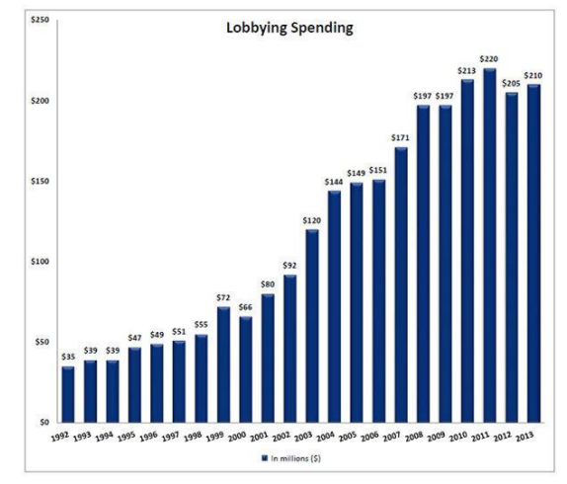
Source:
www.northcountypublicradio.org

Graph B | Graph C
Source: www.vox.com  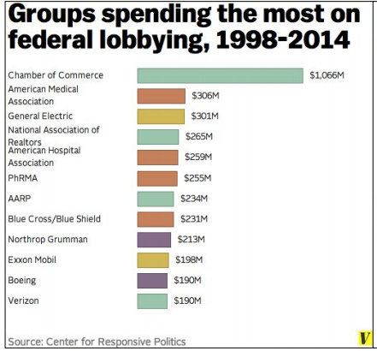 | Source: www.vox.com  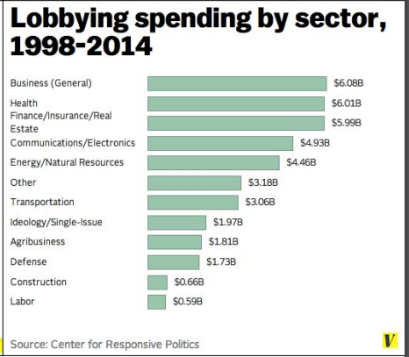

Appendix C

Reasons to Hire a Lobbyist
Source: gaebler.com

Even though good lobbyists aren't cheap, there are plenty of reasons why hiring a lobbyist may be the best way to gain the attention of government agencies and elected officials.

- Experience. Could you send a company executive to Washington to try and get the attention of lawmakers and government agencies? Sure. In fact, it might be a lot cheaper than hiring a lobbyist to do it for you. But let's face it, unless your exec has lobbying experience, he won't have any idea what he's doing and the odds of success will be slim. In some cases, inexperience can even generate the kind of attention that is counterproductive to your cause.

- Strategy. Good lobbyists are expert strategists. Their experience has given them firsthand knowledge about how the game is played and the players themselves. It's also given them insight about how to design strategies that will get results for their clients. As in business, many government decisions often boil down to funding, and professional lobbyists are skilled at devising funding strategies that make it easy for legislators to say "yes".

- Personal contacts. Ever wonder why the ranks of professional lobbying firms are swollen with former lawmakers and legislative aides? Personal contacts. Relationships are important in government and the most successful lobbyists are those who share a history with the people who are currently in power. Unless you have those kinds of personal relationships, you'll need a lobbyist to enter the inner circle of trust with some government players.

- Speed. When everything is said and done, paid lobbyists get the job done faster than people who do their own lobbying. There are no guarantees that the lobbyist will be able to deliver your desired outcomes. But if it can be done, a good lobbyist will usually accomplish it much sooner than you could have – and that's an important consideration if you're dealing with a time-sensitive issue.

Appendix D

Name _______________________________________________

Assessment #1

- Define: Special Interest Group.

2. What are two reasons why Special Interest Groups hire professional Lobbyists?
1.
2.

3. List 2 Special Interest Groups who would be affected by the Bills below.

Bill | 2 Special Interest Groups Affected...
1. A bill that would raise the minimum wage in New York State.
2. A bill that would raise taxes on gasoline purchased in New York State.

4. What right protects both professional lobbyists and an average citizen’s ability to lobby the government?

Part II:
- Appendix E – Student Group Presentation
- Appendix F – Issues for Student Groups
- Appendix G – Citizen Lobbying Actions
- Appendix H – Citizen Lobbying Background Materials
- Appendix I – Group Presentation Rubric

Appendix I – Group Presentation Rubric

Name _______________________

Group Topic You are Observing ___________________________

Group Presentation Rubrics
Directions: After watching a groups presentation, circle where you believe they belong on the rubric. Don’t forget to explain your decision in the right hand column.

 | 4 | 3 | 2 | 1 | Explanation
Decision Makers | Choose the Correct Decision Makers | Good Decision Makers, but could have chosen better | Vague Choice of Decision Makers | Incorrect  Decision Makers
Special Interest Groups | 4 Correct Special Interest Groups Identified | 3 Correct Special Interest Groups  Identified | 2 Correct Special Interest Groups  Identified | 1 Correct Special Interest Group Identified
Action Chosen | Chose 3 Strong and Appropriate Actions | Chose 2 Strong and Appropriate Actions | Chose 1 Strong and Appropriate Action | Chose Incorrect or No Actions
Action Details | Strong level of detail in planning Actions | Good level of detail in planning Actions | Vague level of detail in planning Actions | Had little or no detail in planning of Actions
Action Goals | Goals were both realistic and detailed | Goals were realistic or detailed | Goals were neither realistic or detailed | Goals were vague or missing

