Lesson Title: Comparing Federal and State Government

Author: Jody Butts, Susquehanna Valley High School
Revised August 2019, Lisa Kissinger, Shenendehowa High School

Lesson Outcomes:
- Compare responsibilities of U.S. and New York State government.
- Identify the branches of state government and the makeup of New York State’s legislature
- Explore the backgrounds and demographic characteristics of local and state officials
- Draw conclusions about opportunities to participate in local government

Alignment to New York State Social Studies Curriculum Framework:
12.G1e The powers not delegated specifically in the Constitution are reserved to the states. Though the powers and responsibilities of the federal government have expanded over time, there is an ongoing debate over this shift in power and responsibility.

12.G3d Citizens have the right to represent their locality, state, or country as elected officials. Candidates develop a campaign, when they decide to seek public office.

12.G5 PUBLIC POLICY: All levels of government—local, state, and federal—are involved in shaping public policy and responding to public policy issues, all of which influence our lives beyond what appears in the Constitution. Engaged citizens understand how to find, monitor, evaluate, and respond to information on public policy issues.
12.G5c Successful implementation of government policy often requires cooperation between many levels of government, as well as the cooperation of other public and private institutions. Conflicts between different levels of government sometimes emerge due to different goals, ideas, and resources regarding the creation and implementation of policy.

Alignment to New York State Social Studies Practices:
F. Civic Participation
4. Identify, describe, and contrast the roles of the individual in opportunities for social and political participation in different societies.

Lesson Materials and Procedures:

Materials:
- Copies of worksheets
- Large paper for brainstorming
- Markers
- Access to the Internet
- Local Municipality Website
- Web Site on NYS Division of Government https://www.dos.ny.gov/lg/localgovs.html
- PowerPoint Presentation: New York State Government.
- Appendix A: New York Local Government (map with counties)
- Appendix B: New York City Government Flow Chart
- Appendix C: Make-up of New York State County Government (state vs. Federal)
- Appendix D: Make-up of County Government (Seneca County example)
- Appendix E: State and Local Government Position cards or New York City Government Position Cards printed out, cut up and shuffled. State level officials have been done to use as models.

Note: For more detailed background information about local government in New York State, please consult the New York State Local Government Handbook, published by the New York State Department of State, Division of Local Government Services, 2018, https://www.dos.ny.gov/lg/publications/Local_Government_Handbook.pdf

Procedures:
Part I:
- Use the provided presentation New York State Government for a brief overview of New York State’s government structure.
- As you go through the presentation, pay special attention to slides 3-5 to insure that students understand the differences between New York State and the U.S. federal government. It may be helpful to print slide 3 out and provide a copy to each student.
  - Using the Internet, research the names of the current officials holding these positions and add that information to the chart.
    - Extension: Research the addresses for these officials and locate them on a map. Look for their contact information (i.e., phone, email.) Discuss whether it was difficult or easy to find this information.
- Discuss the reasons for, and the similarities and differences between the powers of the federal and state government, and the structure of both.
- Explain that New York State government has two levels -- the state level and local level. Use the image NY Local Government (Appendix A) to highlight the different types of local government in New York. Explain that New York City’s government has a different structure than other cities in New York. Reference the New York City Government flow chart (Appendix B) if desired. Note that it is very complicated.
- Students should identify whether they live in a city, town or village. They should also be able to identify the county in which they live.
- The rest of the lesson focuses primarily on the executive branch of local government. The lesson can be focused on either the form of local government most relevant to the community (i.e., city, town, village or county) or on an issue of student concern.
- If the focus of the lesson is on county government, note that there are different types of county governments throughout New York. Appendix C (Make-Up of NYS County Government Worksheet shows Seneca County’s structure. Seneca County has a county manager and a legislature made up of Supervisors. Students can be assigned to research their local county to determine the type of administrative official and legislative bodies.
- For more information on county government services, consult the New York State Association of Counties Publication “101 Ways Counties Serve New Yorkers and Strengthen the Quality of Our Communities.” https://www.nysac.org/files/101%20Ways%203_26_19.pdf.
- If the focus of the lesson from this point forward is on city government, note that there are different types of city governments throughout New York. Appendix B is a flow chart of New York City government.
- Consult the Local Government Handbook for detailed explanations of the city, town and village governments.

- Assign students to identify the important local government officials and make a specific note of which offices are elected and which are appointed.
- Ask students to identify the positions in local government that are similar to state and federal positions. Ask students to research which local government agencies provide services to citizens.
- In small groups, research other positions that are part of the local government in their community.
  - Examples: Mayor, town supervisor, city council, town councilman, city councilman, town clerk, highway superintendent, town justice, city clerk, city judges, justice of the peace, tax assessor, tax collector.
  - New York City: Mayor, Public Advocate, City Comptroller, Community Board. Website: https://www1.nyc.gov/
8. As a class, discuss whether the government positions seem to be similar or different on the three levels.

Check for Understanding:
- To check students’ understanding, ask them to write a paragraph about their opinion of the amount of government. Do they see any redundancies or unnecessary agencies? What qualifications do they think are necessary to hold these local government positions?

Part II:
- Explain that students will learn more about the offices in state and local government. Give each student a position card. New York City position cards are also provided (Appendix D). To customize the lesson for your community, students should fill in the names of the specific office holders listed on the cards.
- Assign students to research the person currently holding the position that they have on their card. Some ideas for questions that they could answer:
    - What party are they from?
    - When were they elected?
    - How long have they served?
    - When are they up for re-election?
    - Have they authored any bills?
  - Note: If you need more cards, add additional elected officials from the local or state level.
  - Mark three corners of the room with “LOCAL, COUNTY and STATE”. Using the cards they have been given, have students move to the proper corner of the room.
  - Ask students to check everyone in the group and decide if they are all in the correct corner; correcting any errors as necessary. Ask students to report out on the officials they have researched.
  - With the students, create categories to analyze the information they have gathered. For example -- are the political parties consistent at both the local, county and state levels? Are the officials similar in demographics (i.e., age, gender, education). Which level of government seems to have officials who serve the longest (or, which level of government has the greatest turnover?) Does there seem to be a pattern in the experience that the officials have - in other words - did most of the state officials from this region begin as local officials?

Check for understanding:
Respond to these questions:
- Are the local officials of this region/community/state representative of the community’s demographics? Does that matter?
- Do you think it would be easy or difficult to run for local office?
- What do you think would happen if the officials from the local, county and state did not work together well?

Extensions:
- In the lesson “Political Action in your Community,” students research issues in their own community and develop an action plan to address the issue.
- In the lesson “The Judicial System,” students will investigate the New York State Judicial Branch in more depth.
- Attend a local government meeting, or read local government meeting minutes to learn about topics that are currently being debated in their local communities.

Appendix A

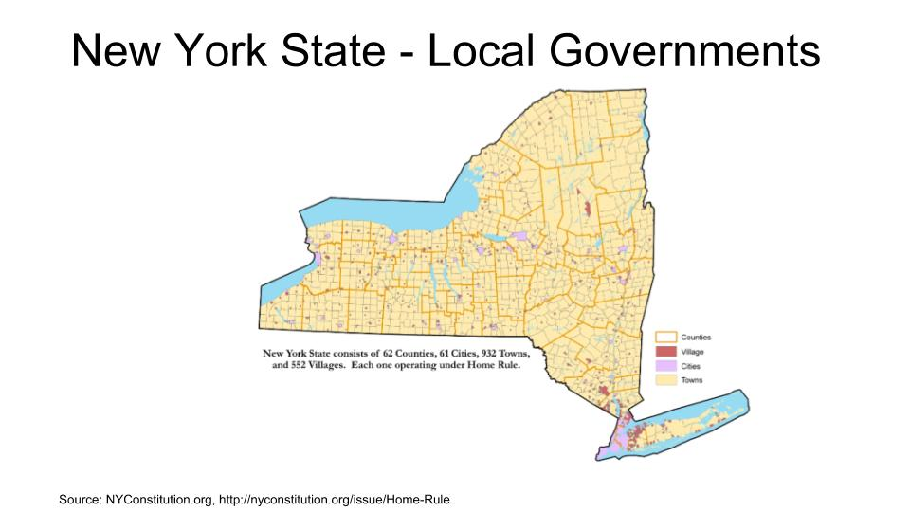
Appendix B
Structure of New York City Government
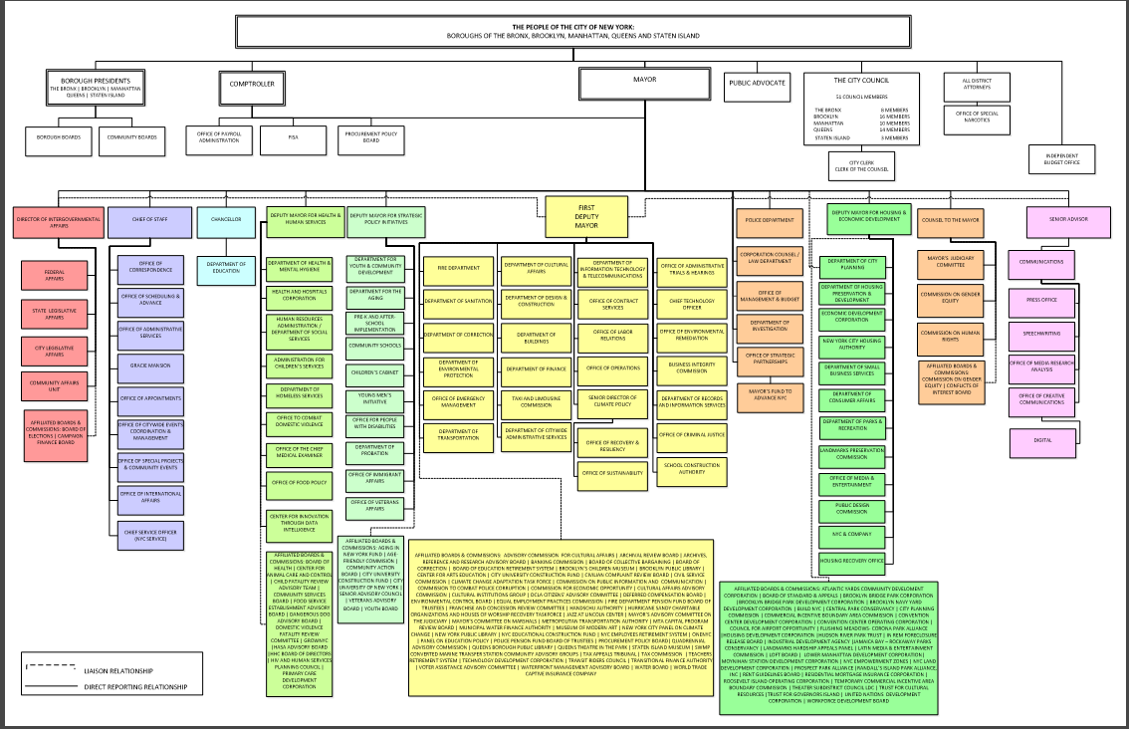
Appendix C

Make Up of New York State Government in Comparison to United States Federal Government
 | New York State | Federal Government
Executive | Governor (4 year term, no term limit)  Lieutenant Governor (nominated, on same ticket as Governor) | President (4 year term, 2 term limit)  Vice-President (nominated, on same ticket as President)
Legislative Bodies | Assembly (2 year term, no term limits)  150 Assembly Members  Senate (2 year term, no term limits)  63 Senators | Congress (2 year term, no term limits)  535 Members of Congress  Senate (6 year term, no term limits)  100 Senators
Judicial | Court of Appeals is Highest  Appellate Court is Middle  Supreme Court is Lowest | Supreme Court is Highest
Authority of Dept. of Justice | Attorney General (Elected by People, 4 year term)  Currently: | Attorney General (Appointed by President)  Currently:
Fiscal Authority | Comptroller (Elected by people, 4 year term)  Currently: | Secretary of  United States Department of the Treasury (Appointed by President)  Currently:
Make Up of New York State County Government
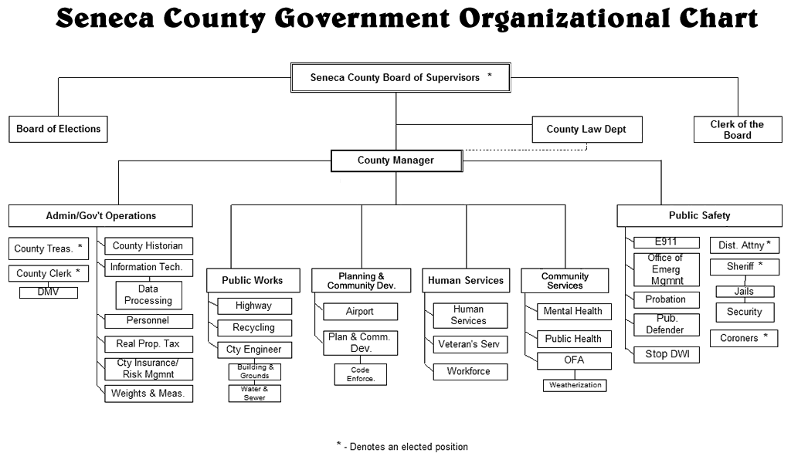Source: https://www.co.seneca.ny.us/departments/dhs-administration/children-family-services/

Appendix E
New York State Government Position Cards
Governor  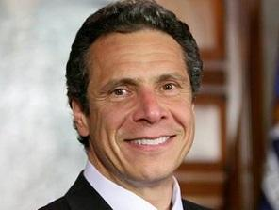 | Lt. Governor | Mayor  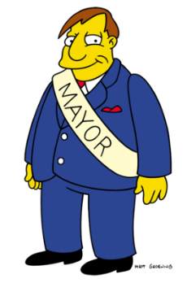 | Sheriff
District Attorney | Coroner | County Treasurer | County Clerk
Board of Supervisors | State Assemblyman  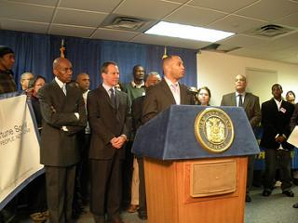 | State Senator | County Executive  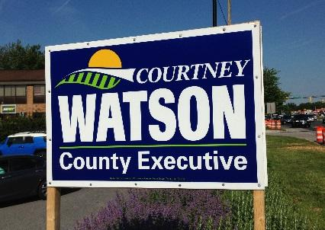
Town Councilman | County Legislature | City Councilman | Comptroller
Attorney General | County Judges  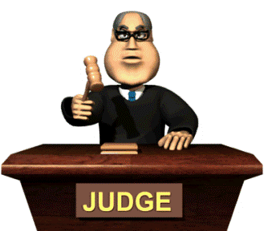 | State Supreme Court Judges  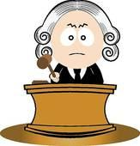 | Tax Assessor  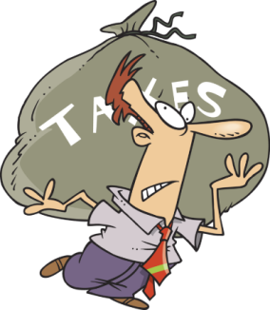

New York City Government Position Cards
Governor | Lt. Governor  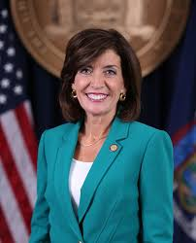 | Mayor | Public Advocate
NY torney General | Coroner | City Comptroller | Chief of Police
Borough President | State Assemblymember | State Senator | City Council President
City Council Member | Community Boards | District Attorney | NY Comptroller  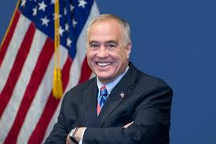
 | Judges | New York State Court of Appeals

