Make Up of New York State County Government
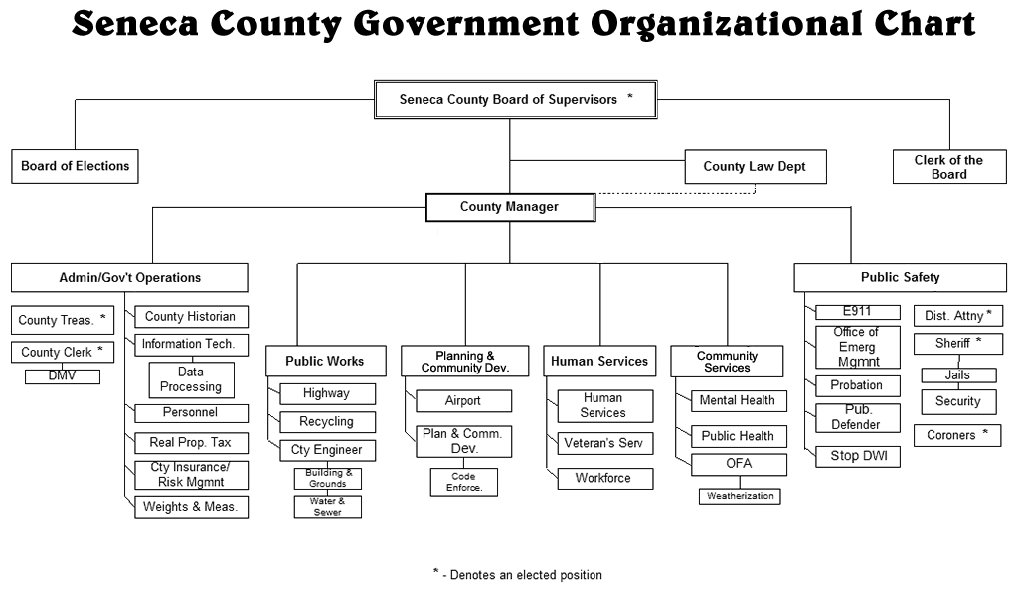Source: https://www.co.seneca.ny.us/departments/dhs-administration/children-family-services/

