Name _____________________________________
Board of Elections Internship Project
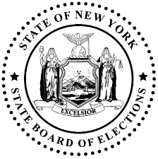

You got it! The final internship for your Policy program is with the Board of Elections. You have to increase voter turnout in the district of your university. There are a couple of small problems, one is that your major is health administration and the second is you are from Hawaii and you don’t know much about NYS. You will need to familiarize yourself with the diversity of NY state voters and their values, analyze voting behaviors in recent national elections, create a voter profile for the district you are working in and create a quick voter guide to distribute to the community. Better get moving, you graduate in 3 months! Follow the steps below:
Step 1: Familiarize yourself with some voters from across the state by watching this NYS Voter video
Step 2: Analyze party enrollment data, election results, and exit polls to create a “cheat sheet” listing 10 characteristics of the NY State Voter. All sources are included on cheat sheet.
Step 3: Narrow in the data to create a quick district/ county profile (p.2) of the district you are working in to include in quick voter guide for the district including.
Step 4: Create a voter guide to include: registration deadlines, upcoming elections, how to find your voting place, access to a sample ballot, informing citizens about “Time off to Vote,” and why we should vote. Check your work with the rubric to ensure optimal success.
Step 5: (optional, but will likely get you the honors rope at graduation): Analyze the reasons New Yorkers have poor voter turnout and organize a public outreach campaign to improve voter turnout!

