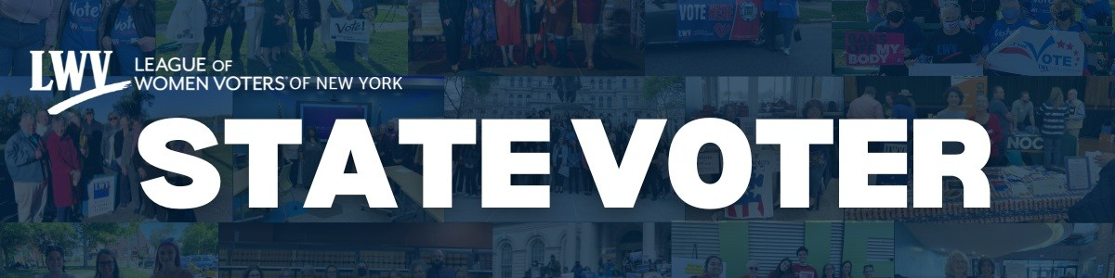

Protect the Vote, Protect the Future November 2025

Democracy thrives when every voice is heard and every vote counts. Together, we stand as protectors of that promise, uniting each month to champion fairness, strengthen participation, and defend the rights that keep our democracy alive.

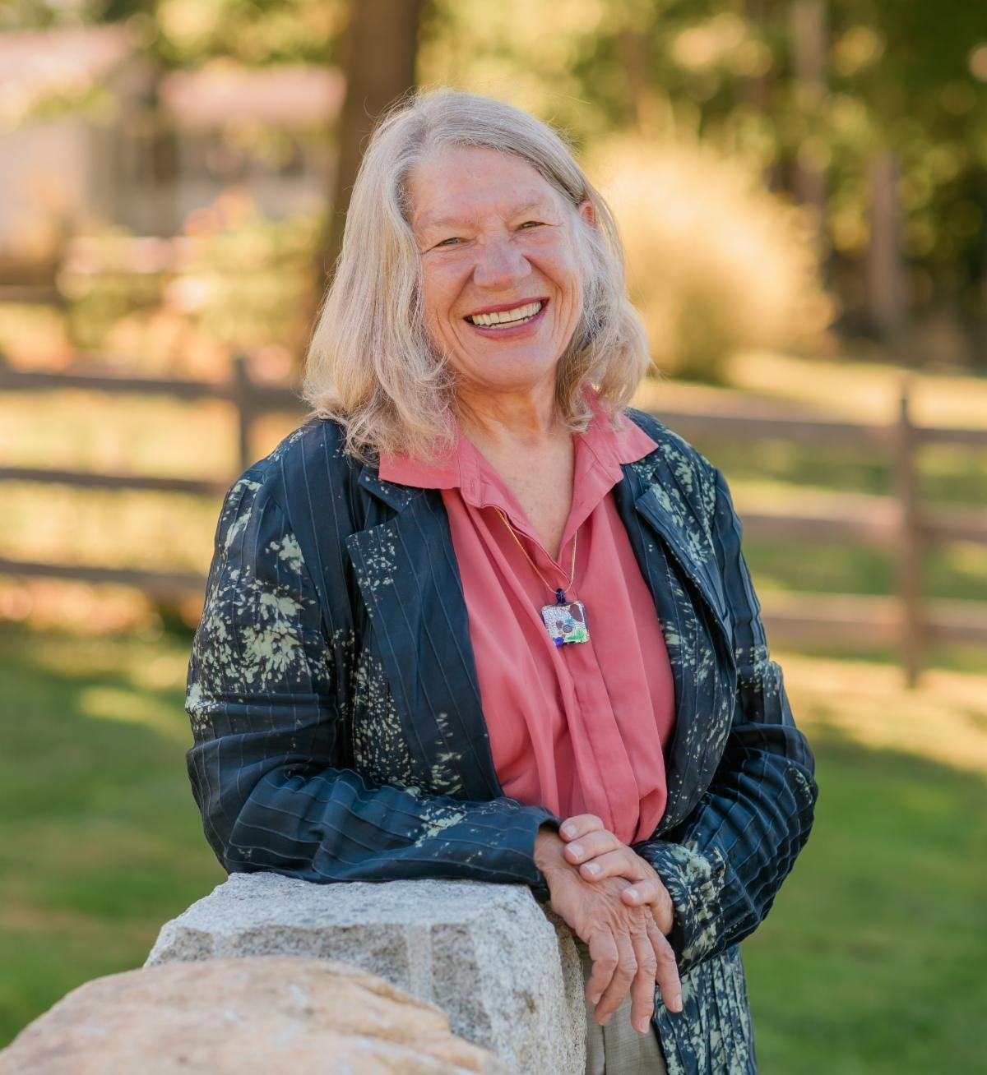
State Leaders Message

Nancy Rosenthal, President, nancyrosenthal9@gmail.com
Erica Smitka, Executive Director, erica@lwvny.org

A huge thank-you to our local Leagues for continuing to promote VOTE411. By sharing it through social media, texts, and emails, we empower voters right where they are by helping them make informed choices. We’re also
seeing voters use early voting exactly as intended, and that’s a success worth celebrating. New York City has seen record breaking early voting numbers!

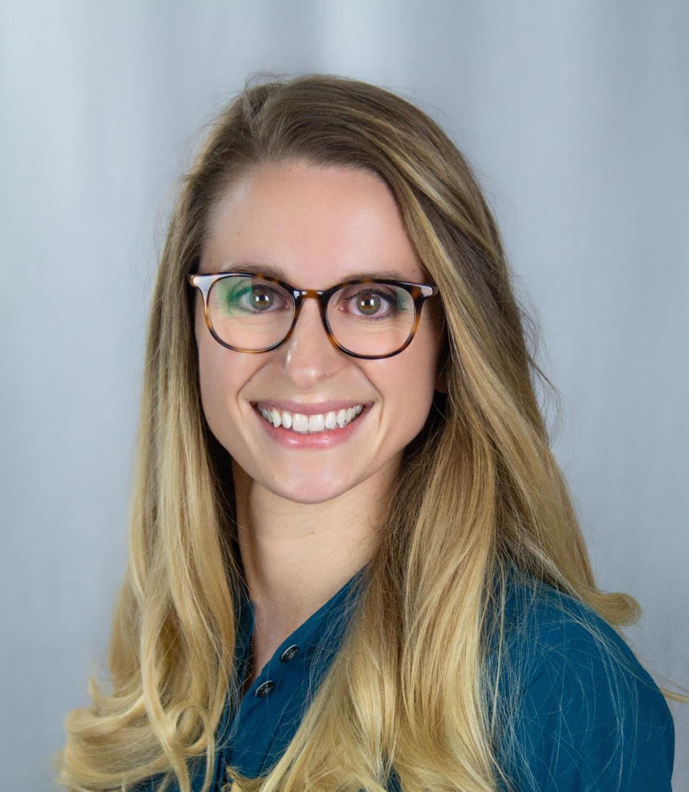
Things are moving quickly these days — we all feel it. Let’s keep communicating with one another to stay consistent and clear in how we hold our elected officials accountable. The League of Women Voters never endorses or opposes candidates or political parties. But we absolutely have the right, and the responsibility, to hold elected officials accountable, on Election Day and every day. Doing so is not a partisan act; it’s a cornerstone of our democracy.

If you or anyone you know has difficulty voting or has a problem at their poll site tell them to call the Election Protection Hotline at 1-866-OUR-VOTE. Let's get ready for a successful election day!

In League, Nancy and Erica

LWVNYS Board Announcements

Voter Services

Jane Colvin, 2nd Vice President/ Voter Services

Congratulations to Leagues that participated so successfully in the No Kings Day rallies across the state! I hope all your election-day preparations were rewarding and productive

as well – registering, educating, GOTV-ing the voters to the polls! As of today's "The Voter", there are two remaining Key Date Deadlines: November 3 – Last day to request an absentee or early mail ballot in person, and November 4 – Ballots must be mailed or dropped off by today, Election Day. And just in case, here's the recorded webinar hosted by the State League for more information about the state-wide ballot proposition #1 concerning the Adirondack forest preserve.

We want to highlight the importance of data collection at the local League level, especially during this busy time! Twice a year we ask local Leagues to complete a survey in which we ask detailed information about their Voter Service events and activities. It helps all Leagues! In addition to celebrating our voter service activities, there are two reasons why this receiving this information is so important – 1) for grant applications, when we present our case for funding by listing the many impactful events and activities Leagues conduct, and 2) to answer donors who have two questions upmost in their minds: how will their money be used and what impact will it have. But recently, the strategic value of having this information available became overwhelmingly apparent as we filed to intervene in the lawsuit the Department of Justice filed against the Board of Elections of New York State. When lawyers asked us to provide data about League activities, we had the facts and were able to do our part.

One of the data highlights from 2024 is that we registered over 14,000 voters and distributed over 100k pieces of get out the vote information. Thank you so much for all that you do!!

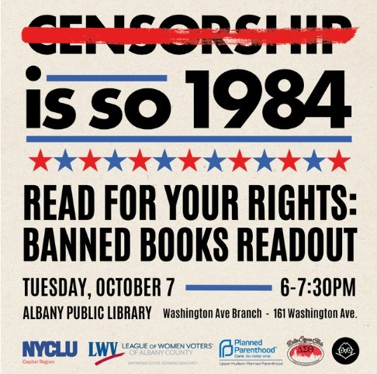
Diversity, Equity, and Inclusion Regina Tillman, 3rd Vice President/ Diversity, Equity & Inclusion
Our State DEI Committee meeting of October 6th was well worth the wait! At the top of the meeting, most attendees took the opportunity provided to them to speak to their local DEI-related efforts since meeting last June. This practice, continued from previous years, allows the sharing that is as much informative as it is building comradery, albeit, on a virtual basis. And the value in ‘sharing & comparing’ amongst colleagues doing similar work can never be understated.

To read more from our 3rd Vice President, click here.

Local League Support

Marjorie McIntosh, 4th Vice President/ Local League Support

All of the local leagues within each of our five NYS regions are set to hold their quarterly meetings in November, which is approaching quickly!

In between scheduled meetings, individual regions stay in touch with each other with updates, projects, concerns and successes about a variety of timely topics. The regions are cohesive units with many talents and creative ideas, willing to share within each group as well as with other regions.

Most, if not all, of our local leagues participated in No Kings rallies last weekend, with varying levels of engagement. The numbers of committed League members with all other passionate citizens across the country was staggering and encouraging. It makes us proud. Local leagues have been busy registering voters, providing accurate information, hosting candidate forums and GOTV initiatives and all of this in addition to high school, college, community outreach projects. It is quite amazing how much we accomplish!

More local league updates and activities will be shared in the next State Voter. It's

exciting to see what we are all doing!

Updates from the State League

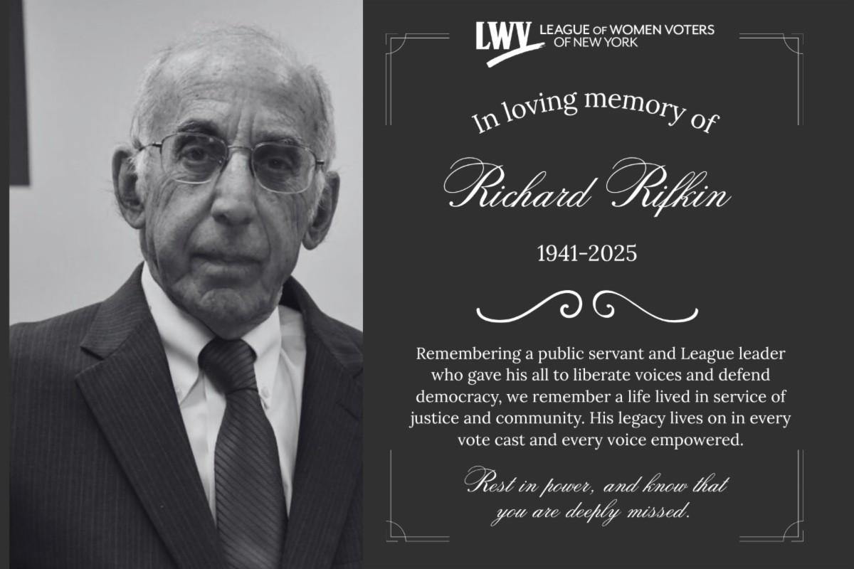
The League of Women Voters NYS mourns the loss of a remarkable League leader, Richard Rifkin.
Richard's life was a beacon of service, wisdom, and unwavering dedication to the community he so deeply loved.
Richard Rifkin's tireless work to uplift others and his passion for educating and empowering future generations will echo for years to come. Though he may be gone, his legacy lives on in
every life he touched and every lesson he shared. Rest in power. To read Richard's full obituary, visit the link.
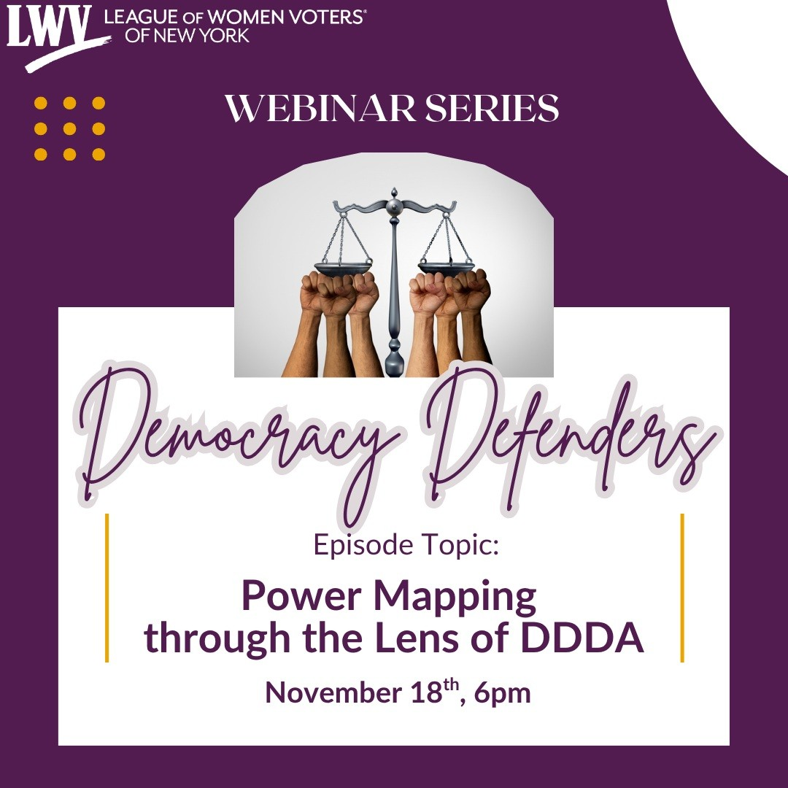
Join us in becoming a Democracy Defender! The League of Women Voters of New York State thanks all who attended last month’s episodes of our civic education and advocacy webinar series, Democracy
Defenders. If you missed our previous episodes, click here to view.

For our next episode we will hear from our LWVNYS Campaign Director, Clyanna Lightbourn to dive into the effects power mapping has on voter eligibility for incarcerated voters. During this webinar we will discuss the importance of the Democracy During Detention Act and learn more about the campaign.

Join us November 18th at 6pm, register TODAY!

League of Women Voters of New York State Seeks to Intervene in Lawsuit to Protect Sensitive Voter Information On October 25th, the League of Women Voters of New York State, represented by Campaign Legal Center (CLC) and the Brennan Center for Justice at NYU School of Law (Brennan Center), filed a motion to intervene as a defendant in a lawsuit brought by the US Department of Justice (DOJ) to obtain the complete list of all registered voters in New York without proper basis and purpose. The DOJ is attempting to obtain voters’ sensitive data, including private information such as driver’s license numbers or partial Social Security numbers, data beyond what’s typically publicly available. To read the full press release, click here. Read and listen to some of the news coverage here, here, here, and here.

Important Dates for the November Election
As the general election approaches it is important that we make sure that all members and voters know these essential deadlines in November.

Absentee and Early Vote by Mail Ballot Options | Nov. 3rd is the last day to request a ballot in person at your local board of elections.
Election Day Voting | 2025 General Election  November 4th, 2025

Check status and find polling site here

"No Kings" Rally

It is important for us to be active and visible during this time as we work tirelessly to defend democracy against our rapidly changing government. On October 18, Local Leagues joined community organizations across the state for the “No Kings” rally, standing up for democracy and against any politicians or entities that would put our rights in jeopardy. Here are a few highlights from some of our Local Leagues who participated.
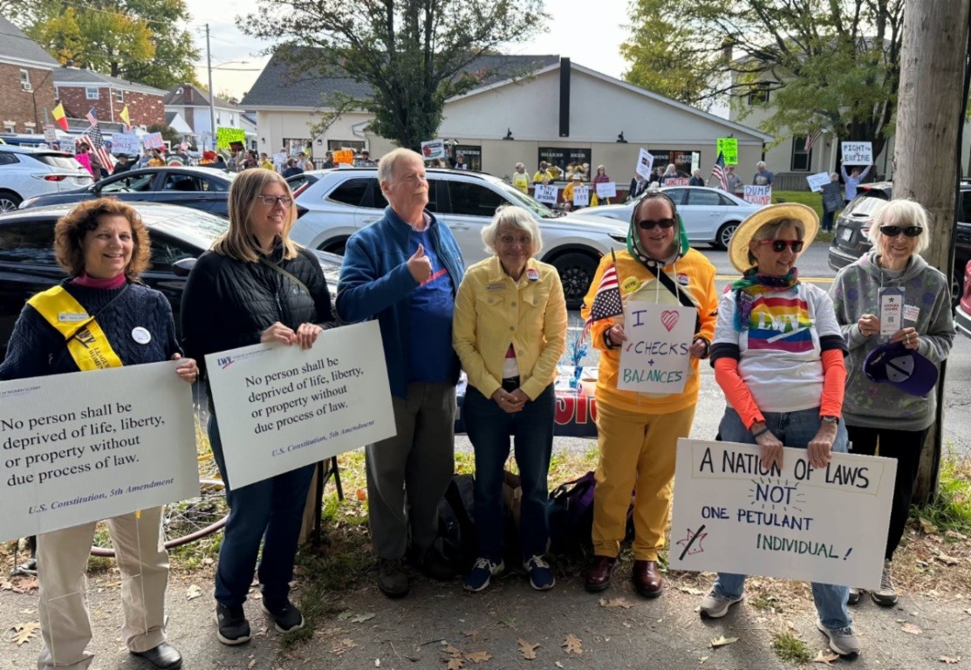
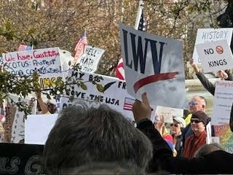

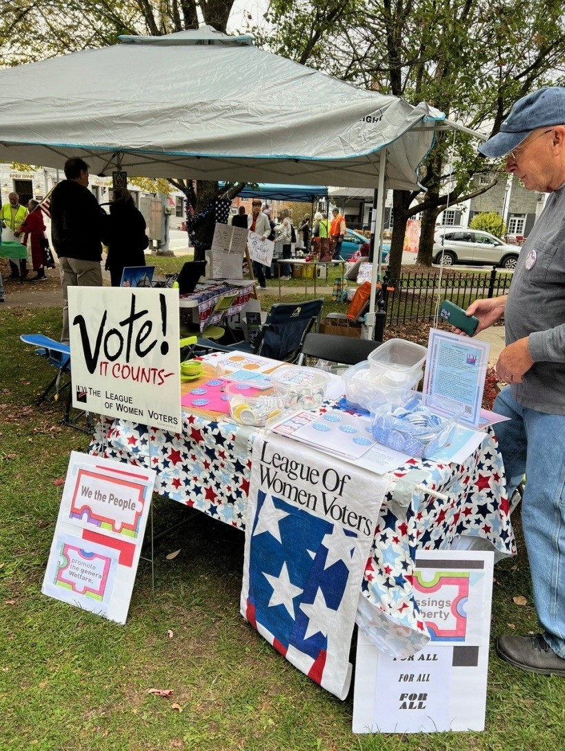
League of Women Voters Cazenovia
League of women Voters Albany County

League of Women Voters Buffalo/Niagara

League of Women Voters of Saratoga County - Watch the League’s "Defending Democracy" remarks by League President, Lori Dawson, at the No Kings rally in Saratoga Springs. The League co-sponsored the event where thousands gathered locally in support of democracy and the constitution. Click here to view.

Local League Happenings
Check out these updates from our Local Leagues!

League of Women Voters of the Hamptons, Shelter Island & North Fork- In October, the LWV of the Hamptons, Shelter Island & North Fork’s Voter Services Committee held five candidate debates, some live and some virtual, for the candidates for Suffolk County Legislature, 2nd L.D., and for the Towns of East Hampton, Southampton, Shelter Island and Southold. We received both pre-and-post event coverage in the local media.
On November 19, our Youth Committee is holding our biannual program called “Running and Winning” for juniors and seniors in our 10 area high schools. Its theme this year is “School Boards, the Training Wheels of Democracy,” with school board trustees as speakers and participants, and includes the new student ex officio school board members, too, to learn how to run for school boards.

League of Women Voters Cortland County- LWV Cortland County has been extremely busy this election season. From building their Vote411 guide to connecting with 97 candidates to gather pertinent information for voters. They organized two virtual "Meet the Candidate" forums and received positive feedback from participants. All while writing long-form articles for their local newspaper. Since starting the project, they have covered topics such as "How a Bill Becomes a Law", "Democracy during Detention", "The Democracy Preservation Act", "From iPhone to First Vote", "Election Year Law", "Mail-in Voting" and our latest: "It's Election Time in Cortland County".

League of Women Voters of Rivertowns- LWV of Rivertowns has been working with Sharon Courtney, Executive Director for Social Studies for Yonkers Public Schools, to register and educate voters in the public schools for the last year. At the start of the 2025 school year, however, she has asked our help in a very creative approach in expanding these efforts. In an effort to reach parents, she asked us to assist with voter registrations during Back-to-School nights not only in high schools, but in the elementary and middle

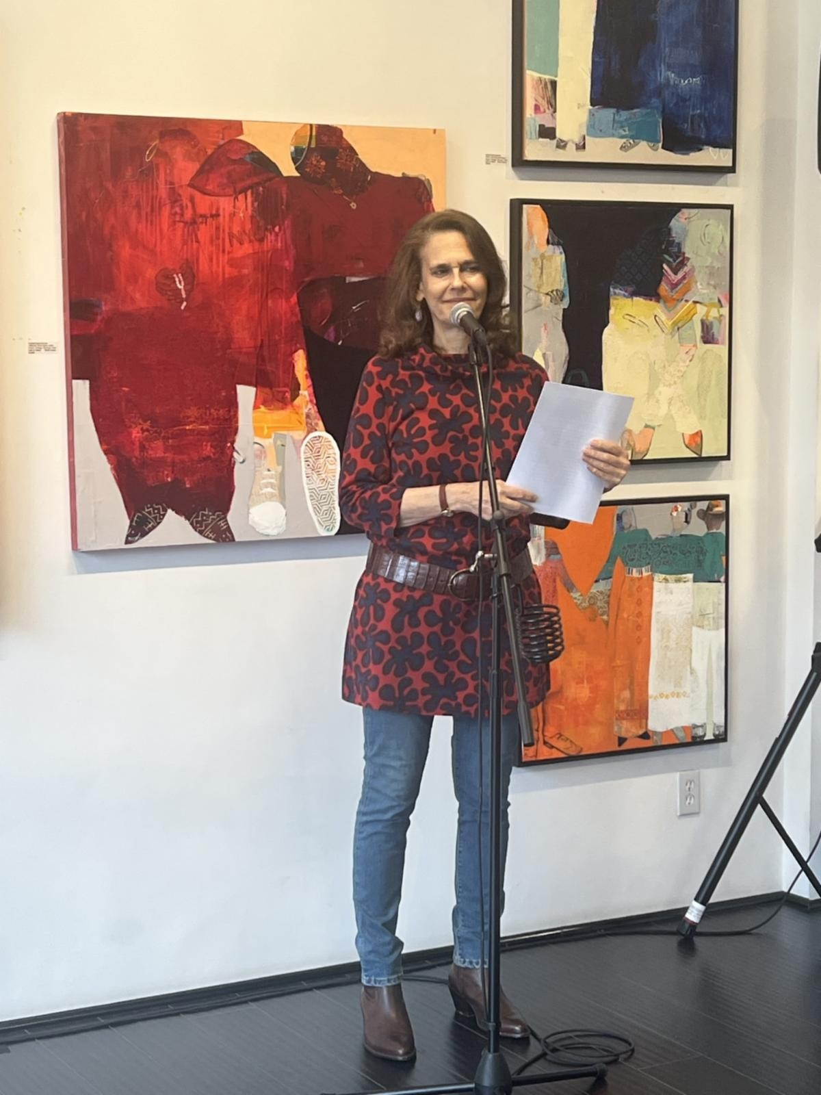schools as well. The schools provided student helpers who were an important part of making these events so successful.

League of Women Voters of Broome-Tioga Counties- On October 20 th the LWVBTC partnered with several community organizations hosted a debate between Binghamton Mayoral Candidates Jared Krahm and Miles Burnett. About a hundred people attended in person or via the on-line screening of the event. Long time League Board Member Karl Wokan served as moderator and Board members Sara Wokan and Carla Michalak handled the time-keeping duties during the debate. The League also distributed voter information to the attendees. Local television stations covered the event. To read more click here.

League of Women Voters of Larchmont/Mamaroneck- On October 11th the Larchmont/Mamaroneck chapter hosted THE ART OF DEMOCRACY at Palmer Art, a local art gallery. The upbeat link between the creative spirit (nonpartisan art), freedom of expression and voting provided an uplifting example of what democracy looks like. The event included Local artists and high school artists, live music, a community canvas for all to contribute to, a community poetry project, readings by their local poetry laureate, outdoor chalk art for kids of all ages and all attendees able to vote for best art in show (because, if course, voting is in the LWV DNA). The Town Clerk gave a voter/voter ed update—we emphasized the benefits of VOTE 411 – one stop for all voter needs—and heard from a local poll worker.

Donate to LWVNYS

Donate to LWVNYS Education Foundation

View as Webpage

League of Women Voters of New York State 1 Steuben Place
Albany, NY 12207

lwvny.org


League of Women Voters of NYS | 1 Steuben Place | Albany, NY 12207 US Unsubscribe | Update Profile | Constant Contact Data Notice

