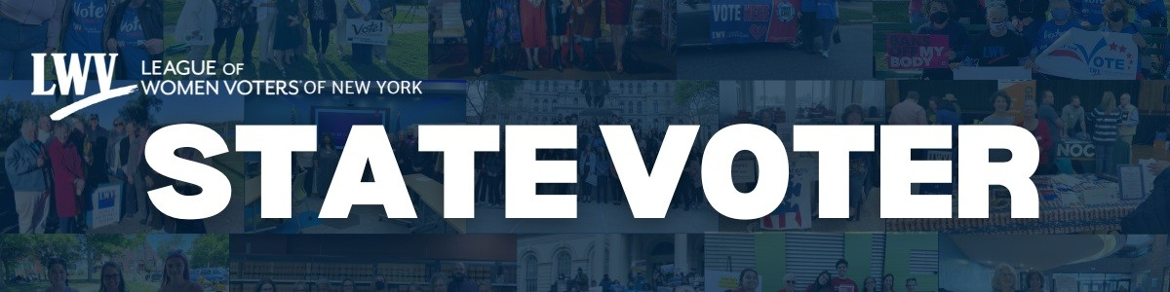

Election Season is Here: Your Vote Your Power October 2025

As we approach the general election, it is important that we continue to empower registered voters to activate their vote and encourage many to register and be civically involved. Continue to do the "Good Work" through this election season.

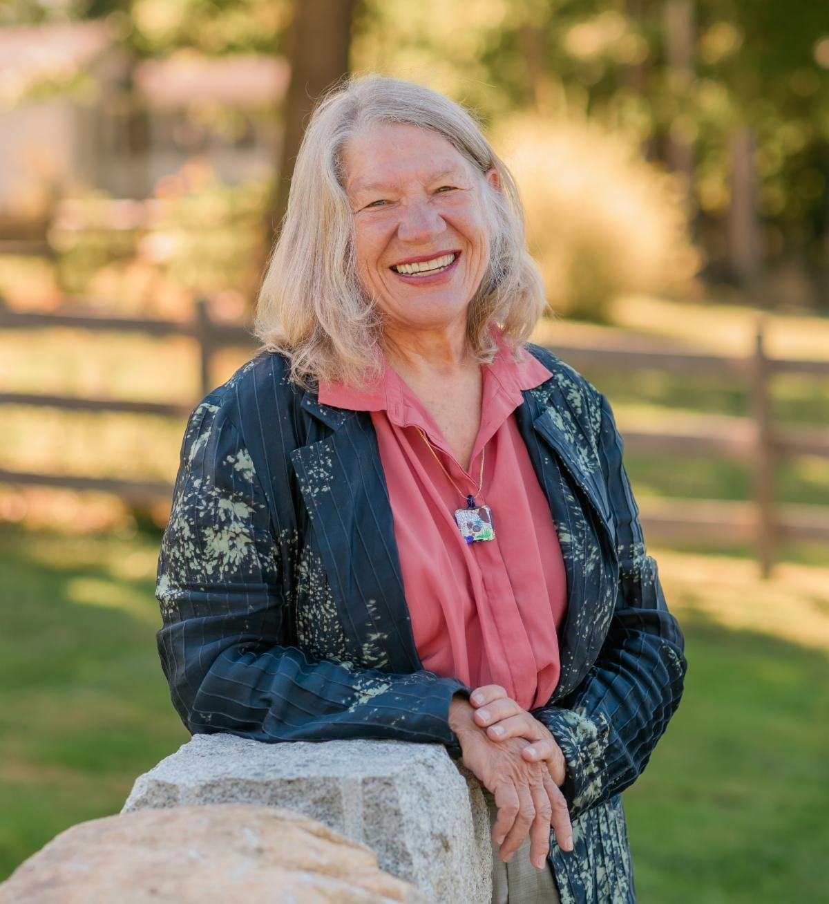
State Leaders Message

Nancy Rosenthal, President, nancyrosenthal9@gmail.com Erica Smitka, Executive Director, erica@lwvny.org

LWVNYS and LWVUS are actively responding to last week’s deeply concerning efforts to undermine the election process, which is constitutionally a state function. We have seen the DOJ request voter information, casting doubt on the independence of state Boards of Elections, while also undercutting the essential, nonpartisan work of organizations
like ours that register voters at naturalization ceremonies and community events. On top of this, there are threats of National Guard deployments, mid-cycle redistricting, and even disturbing rhetoric labeling nonprofits as terrorist organizations.

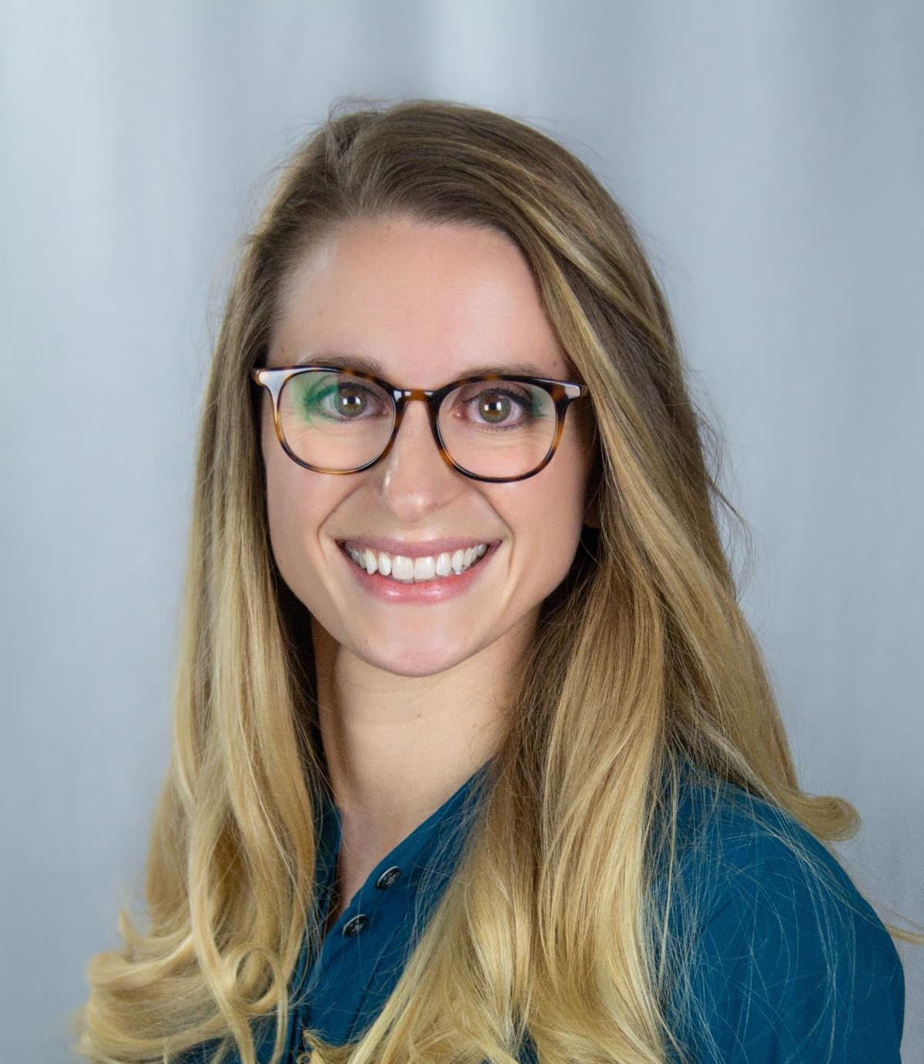
We know how frustrating and alarming this feels. Many of you have asked, “What can we do?” The answer lies in how we have always met moments like this: through collaboration, communication, and steadfast advocacy. We must channel frustration into purposeful action. The League is a national partner in the upcoming No Kings 2 rallies on October 18th. Find a local event to join here.
Now is the time to stay connected, informed, and ready to act. Watch for upcoming advocacy alerts, share information with your communities, and join us in showing that the League’s strength is in our collective voice.

There is now just over one month before the November 4 th election. It's a critical time to push get out the vote efforts and to remind all New Yorkers of the four ways to vote in NYS- in person on election day, in person during early voting, via an absentee ballot, via an early mail ballot. Any registered voter can now vote via early mail ballot, so (if they prefer) voters no longer need to leave the house to cast their ballot. Let us remind members in our community of the power of their voice especially during local election season when races are won and lost by one or two votes. Keep pounding the pavement to register voters by October 25th and let's get New Yorkers to turn out to the polls.

In League, Nancy and Erica

LWVNYS Board Announcements

Voter Services

Jane Colvin, 2nd Vice President/ Voter Services
Voter Service Survey
We accomplished quite a bit across the state, and we are proud of everyone’s dedication to the League. While the Survey’s window of time started after the general election, local Leagues were still quite busy! They worked in their communities by conducting 269 voter registration drives registering an impressive 4,194 voters. Local Leagues also worked with a total of 99 high schools and colleges, interacted with students and fostered civic engagement amongst the students.

You'll note that we've added additional data to the report, not only to establish a historical record of League activities, but also to provide you with perspective and comparisons of your accomplishments during comparable time periods. Click here to view the Survey results.

Review of Empty Chair Policy
Take a Deep Breath: It’s Status Quo The VS Committee and the LWVNY Board have confirmed that the current LWVNY Empty Chair policy will remain in effect without alteration as adopted in 1971. This decision was not taken lightly. In response to the Direction to the Board, the VS Committee studied the pros and cons of the EC policy and its impact on the Leagues’ dual mission of preserving nonpartisanship and educating voters. For 2 ½ months, we listened to the reasons offered by the two local and one state League that do not follow the EC policy and reached out to LWVNY local Leagues to understand how and to what effect they were following the EC policy. At the conclusion, we asked ourselves - and ask that you too consider: How is a single- candidate event not partisan? Even with the most even-handed procedures beforehand and thorough explanations afterward, the League is giving time to a single candidate and by any definition or measure, is partisan – that is what is seen, and heard, and perceived. Single-candidate events compromise the League’s gold standard, with the increasing potential for serious damage to its integrity and the trust it inspires.

We understand that some of you will be disappointed! But our dual mandate of educating voters and preserving nonpartisanship can be achieved by working within the EC policy. Yes, adhering to the EC policy will limit some candidate events, but there are many, many other ways to educate voters that will also create great visibility for the League and keep its nonpartisanship intact. For example, conducting high-visibility events that focus on issues instead of candidates; posting links to candidates’ websites and events where they are appearing; and for the long term, building relationships with Party leaders. Please see the Report here for other ideas!

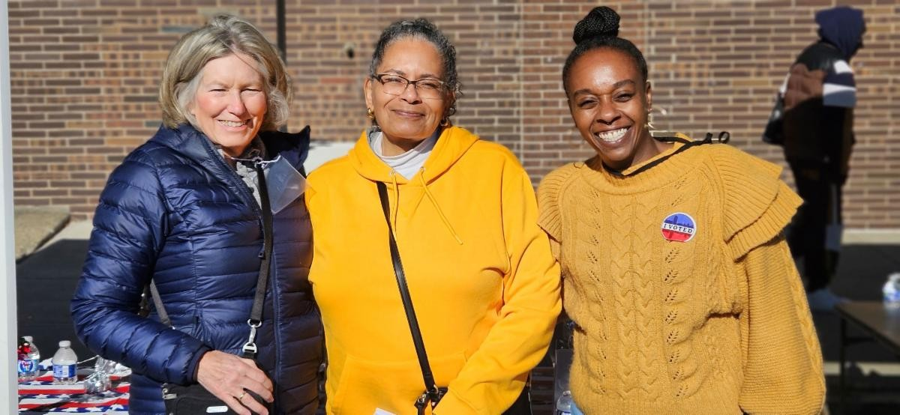
Diversity, Equity, and Inclusion Regina Tillman, 3rd Vice President/ Diversity, Equity & Inclusion
The time for preparing the electorate for voting is upon us! But I hope that perhaps this past summer, upon reflection, will present many of us with pleasant
memories, having had time spent with family and friends, and some new acquaintances.

If you have been wondering what to do in this new membership year, consider the work of broadening the scope and application of the principles of Diversity, Equity, Inclusion, and Access. Looking through a “DEI Lens”, apply it within your League to your policies, procedures and practices, your deployment of resources (making sure they are where most needed), and to your communities in a non-transactional manner. Consider helping to make it understood throughout NYS that, per LWVUS, DEI is not just a buzzword, but rather a set of core values that we need to retain in order to defend and uphold our representative democracy. To read more from our 3rd Vice President, click here.

Local League Support

Marjorie McIntosh, 4th Vice President/ Local League Support

The Local League Support Committee is privileged to have the continuation of our seasoned and regional facilitators, Mary Croxton, Jane Colvin, Kathleen Stein, Judie Gorenstein. We are reluctant to say goodbye to Patti Garrett but are pleased to welcome Chris Alexander as facilitator of the Capital Region. We also welcome Patty MacLeish as an invaluable resource.

Regional meetings are held quarterly and each region determines its own schedule, while trying to keep some consistency - August, November, February and May. Each region develops an agenda with input from members. From time to time, requests for action might come from the state league and the LLSC can act as a communication conduit.

Across the state, all 5 regions, comprised of all NYS local leagues are engaged in common issues such as finding the right balance of non-partisanship, advocacy and activities, as well as specific issues such as Immigration, Homelessness, SIA, Redistricting, Unite and Rise 8.5 and navigating these troubling times in general. Local leagues are also heavily involved in local community topics. The Empty Chair policy was a part of every discussion.

This committee is continuously inspired by the work and commitment to excellence from every one of our local leagues. Yes, we have an ambitious agenda and yes we are just the right people to do it! Every now and then, we need to remind ourselves that we are an amazing group of committed individuals with collective passion and creativity with limitless resilience and positivity, especially when tested.

Important Dates for the November Election
As the general election approaches it is important that we make sure that all members and voters know these essential deadlines before November is here.

Registration | Mail-In and Online Registration due  October 25, 2025  Check status here
Ballot Options | Early Mail Ballot (Oct. 25-Nov. 2) Absentee Ballot (Oct. 25- Nov. 2) Request Ballot here
Early Voting | Early Voting (Oct. 25-Nov. 2)  Find Early Voting Site here
Election Day Voting | 2025 General Election  November 4th, 2025  Check status and find polling site here

Updates from the State League

Election Day Social Media Toolkit In an effort to prepare our Local Leagues for the rapidly approaching election season, League of Women Voters NYS has developed a social media toolkit to prepare voters for the general election.

This toolkit is designed to help you activate and engage voters in your community. Inside, you’ll find

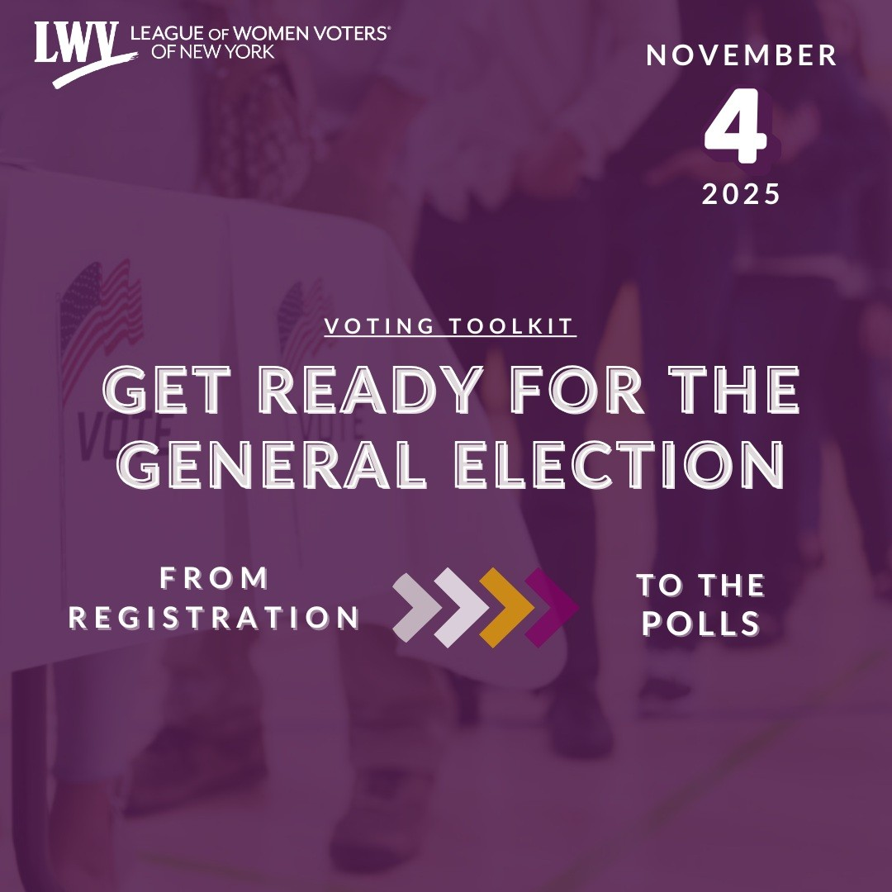
simple resources, like social media templates with key voting information, to make getting involved easier than ever.

Whether you're hosting a voter registration drive, sharing information online, or having one-on-one conversations, this toolkit gives you the tools to take action with confidence. You don’t need to be an expert, just follow the guide, use what works best for you, and help more people get ready to vote. Click here to access the social media toolkit available to your Local League.

LWVNYS Featured on North Country Matters
On September 17th, Executive Director of League of Women Voters NYS, Erica Smitka sat with host Donna Seymour for an episode of North Country Matters. During the episode the two discussed the Leagues response to the political events of 2025 and ways for grassroots advocacy to combat threats to democracy. https://www.youtube.com/watch?v=HY761hOdEYc

Take Action
The ERIC bill and the MAID bill have been passed in the NYS Assembly and Senate! Now is the time for Governor Hochul to sign both bills so they can become law. Call Governor Hochul at 518-474-8390.

Electronic Registration Information Center (ERIC) (S1356A Skoufis/A3649B Taylor) Call Script: My name is (state your name) and I am calling in support of the ERIC bill (S1356A/Assembly Bill 3649B). The ERIC bill is It is the most effective tool available to help election officials maintain more accurate voter rolls. I am calling
on Governor Hochul to sign this bill as soon as possible.

This bill will allow for NY to join a multistate voter list maintenance organization like ERIC. Read more about ERIC and how it works here.

New York Medical Aid in Dying Act (MAID) (S.138 Hoylman-Sigal/A.136 Paulin) Call Script: My name is (state your name) and I am calling in support of Medical Aid in Dying (S138/A136). This bill would prevent needless suffering for terminally ill New Yorkers. I am calling on Governor Hochul to sign this bill as soon as possible.

This bill would afford terminally ill New Yorkers greater peace and the ability to die with dignity. Read more about MAID here.

You can also sign this petition in support of MAID and help deliver the letter in Albany at a rally hosted by our friends at Compassion and Choices on October 8th from 11am-2pm. Find out more here.

Local League Happenings

Check out these updates from our Local Leagues!

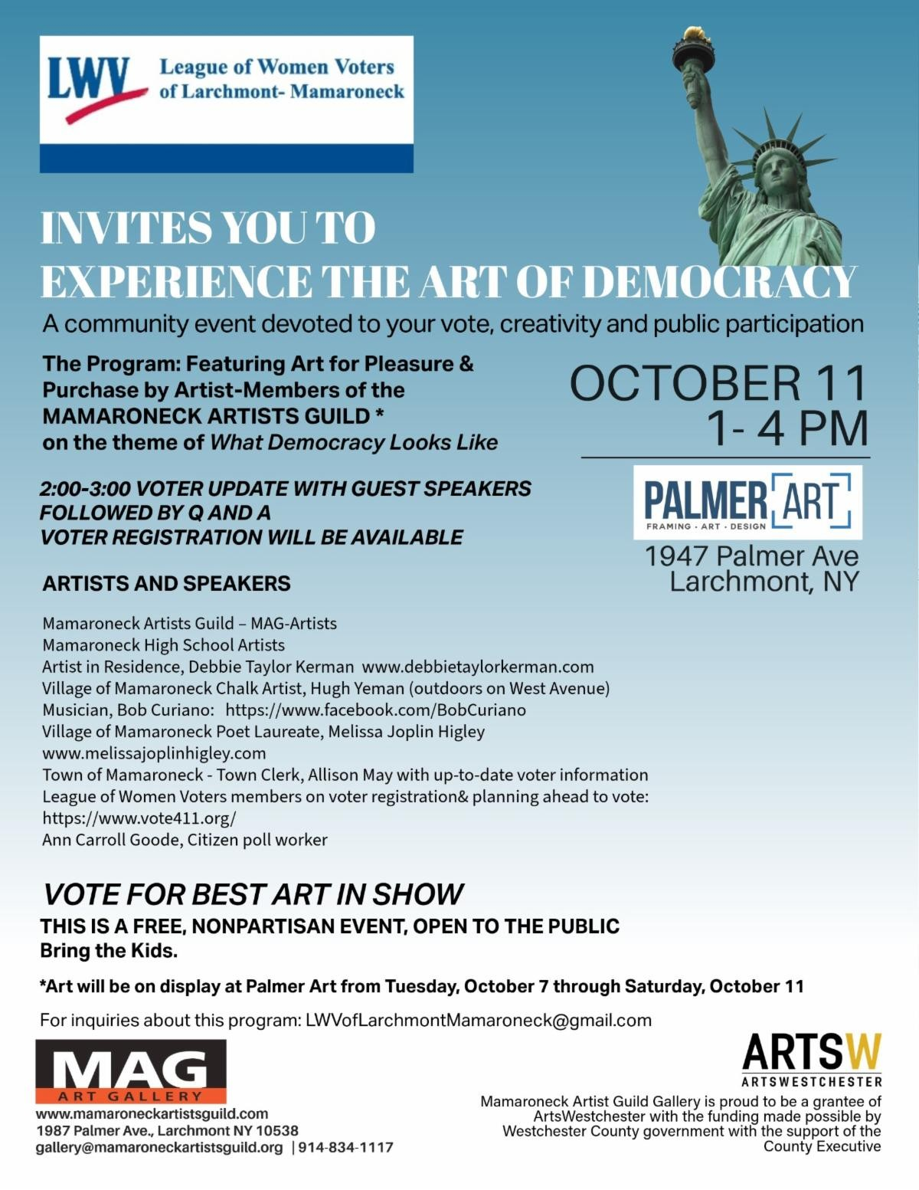
League of Women Voters Larchmont- Mamaroneck- On October 11th at 1pm-4pm, LWV Larchmont- Mamaroneck invite you to experience the Art of Democracy, a community event devoted to your vote, creativity, and public participation. Voting registration will be available, and art will be displayed at the Palmer Art from Oct. 7th- Oct. 11th. For more information about the program, contact LWVofLarchmontMamaroneck@gmail.com

League of Women Voters New Castle- On September 27, LWV New Castle took part in the Chappaqua Children’s

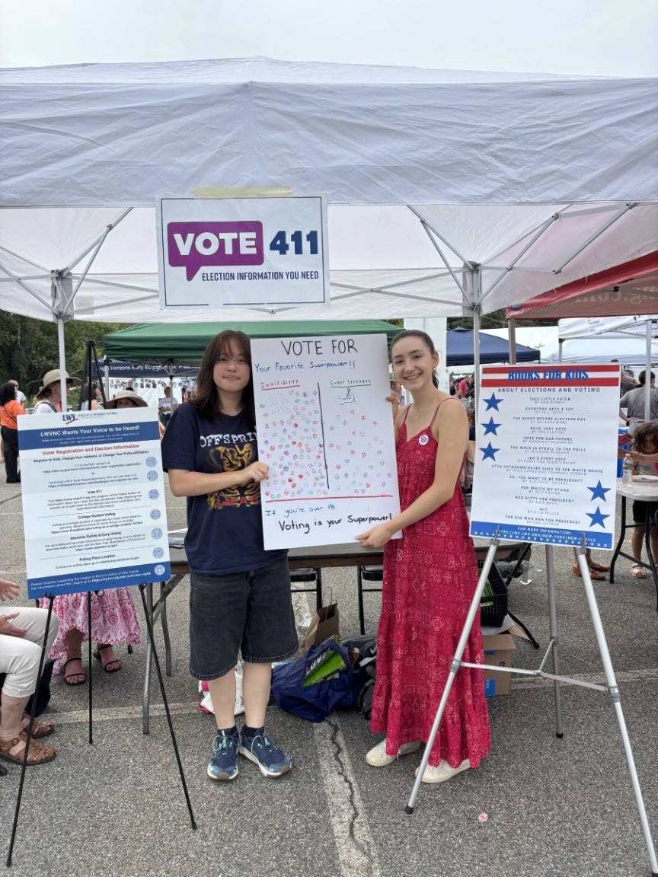
Book Festival by running a sponsor booth to engage with festival goers. Staffed by League members and high school interns, the booth featured information about Vote 411, election disinformation and books for families to read with children about voting. Children who visited the booth got to vote for their favorite superpower (invisibility won by a wide margin!) and were urged to remind their adults that voting is their superpower!

League of Women Voters Brookhaven- On September 22nd, LWV Brookhaven President, Nancy Marr, and Voter Services
Chair, Carole Huston launched their discussion of Unite and Rise 8.5 at a local library with 20 members and one guest present. They used the LWV-US slides and text on Turn Up the Heat to discuss contacting our congressmen to let them know of our concern
with our constitutional crisis.

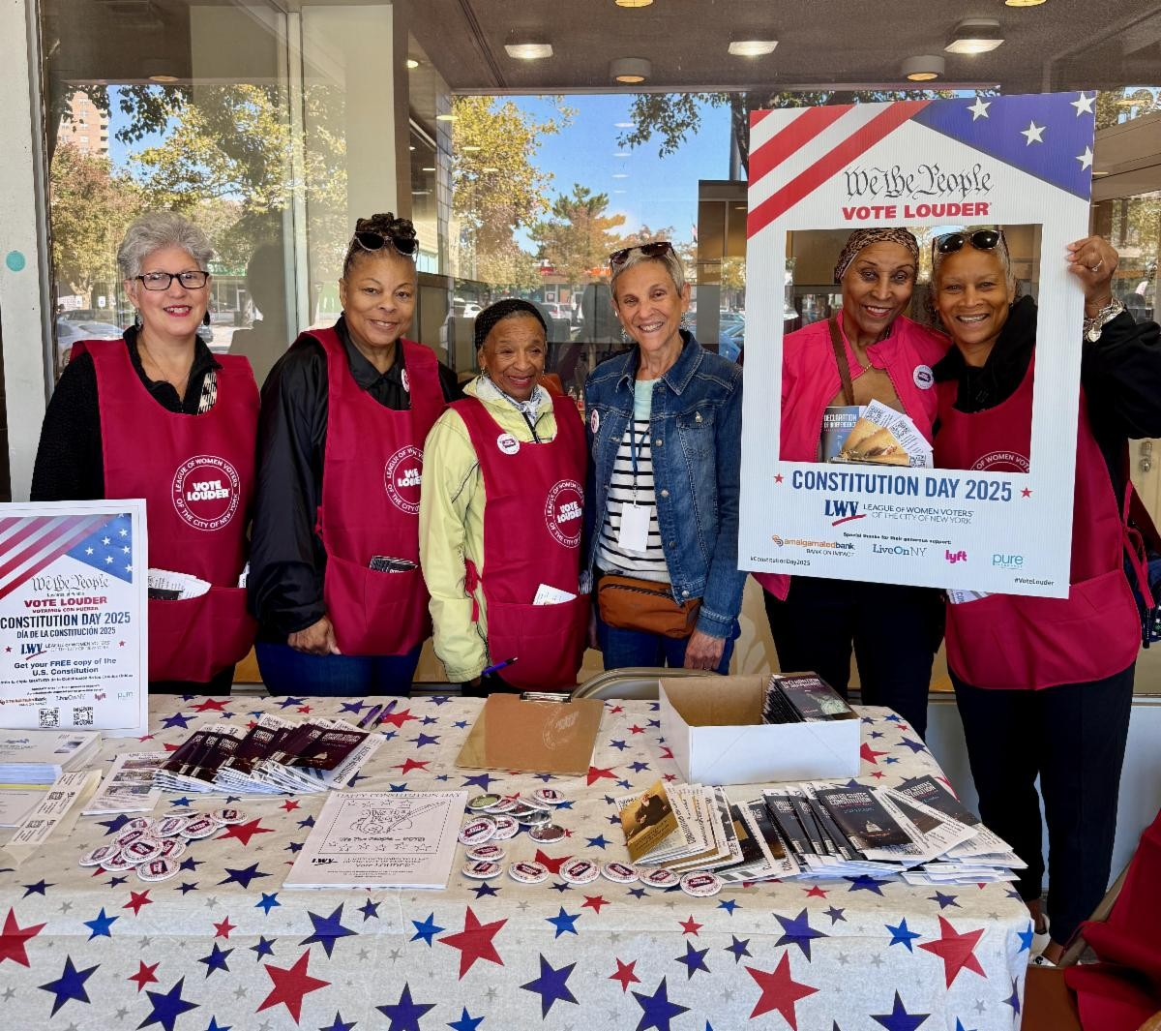
League of Women Voters of New York City- On Saturday, September 20th, the League of Women Voters of NYC distributed over 10,000 copies of the US Constitution at 15 locations around New York City in celebration of Constitution Day. The support of more than 80 volunteers made it possible to inform and empower thousands of New Yorkers in areas with low voter turnout across all 5 boroughs.

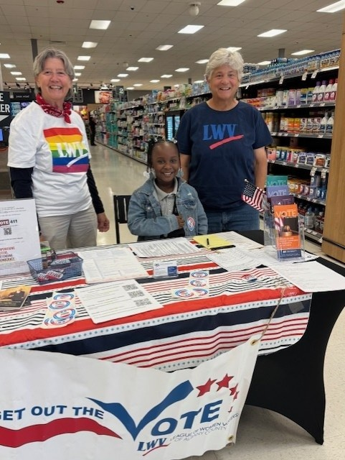
League of Women Voters of Albany County - National Voter Registration Day 9/16/2025 was an opportunity for Leagues in Albany, Schenectady, Rensselaer and Saratoga Counties to team up with area Price Choppers and Market 32s for tabling with voter registration and information. They had an uptick of 30% new volunteers learning the voter registration and education process in the field.

League of Women Voter of Utica-Rome Metro Area- Utica- Rome League was pleased to have registered to vote 29 out of the approximately 40 "New Visions Program" students at the Oneida-Herkimer-Madison BOCES, New Hartford, NY, on September 16th- "National Voter Registration Day!" As usual,
these students were very receptive to learning more about how they can exercise a voice in their governance. The League employed an informative, well put together PowerPoint presentation covering the history of the League and voting in the USA, along with instructions on how to fill out the application, while stressing the importance of obtaining credible information on the candidates and the issues before heading to the polls; e.g., VOTE411!

League of Women Voters of the Cooperstown Area- On September 10 the League of Women Voters of the Cooperstown Area (LWVCA) held “An Evening in Defense of Democracy,” its kick-off event for “Unite & Rise 8.5” The focus was a timely topic: the security of our votes. More than 60 area residents were on hand to hear Otsego County Election Commissioners, Michael Henrici and Lori Lehenbauer, speak on how registration, voting, and ballot counting are carried out by the Board of Elections (BOE). The Commissioners’ talk explained how the BOE staff work to assure that every vote is properly cast and accurately counted. To read more click here.

League of Women Voters of Cattaraugus and Allegany Counties- LWV of Cattaraugus and Allegany Counties has been busy holding VR/Information tables at several local festivals this summer. It was a great way to for LWV Cattaraugus and Allegany to personally interact with many communities across the two-county area and is always a fun and worthwhile

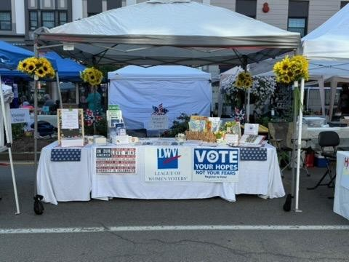
time! Here is the recent Strolean street festival photo and the Emotional Support Bulb that the league offered as a small fundraiser for the Cuba NY Garlic Festival. Special shout out to all the volunteers who attended to share accurate information with fellow citizens!
Donate to LWVNYS

Donate to LWVNYS Education Foundation

View as Webpage

League of Women Voters of New York State 1 Steuben Place
Albany, NY 12207
lwvny.org


League of Women Voters of NYS | 1 Steuben Place | Albany, NY 12207 US Unsubscribe | Update Profile | Constant Contact Data Notice

